|  |  |
| --- | --- |
| **Plate information** | |
|  | |
| **Plate** | 1 |
| **Repeat** | 1 |
| **Barcode** |  |
| **Measured height** | 14.62 |
| **Inside temperature at start** | 23.44 |
| **Inside temperature at end** | 23.44 |
| **Humidity at start** | 51.8 |
| **Humidity at end** | 52.2 |
| **Ambient temperature at start** | 23.25 |
| **Ambient temperature at end** | 23.15 |
| **Group** | 1 |
| **Label** | new alamar blue(1) |
| **ScanX** | 0 |
| **ScanY** | 0 |
| **Measinfo** | De=1st Ex=Top Em=Top Wdw=N/A (14) |
| **Kinetics** | 0 |
| **Measurement date** | 6/30/2023 1:23:08 PM |
|  | |

|  |
| --- |
| **Background information** |
| Legend:  HDR1 - Plate  HDR2 - Label  HDR3 - Result  HDR4 - Signal  HDR5 - Flashes/Time  HDR6 - Meastime  HDR7 - MeasInfo |
| HDR1 HDR2 HDR3 HDR4 HDR5 HDR6 HDR7  1 new alamar blue 0 1359 1 00:00:00.000 De=1st Ex=Top Em=Top Wdw=N/A (14) |
|  |

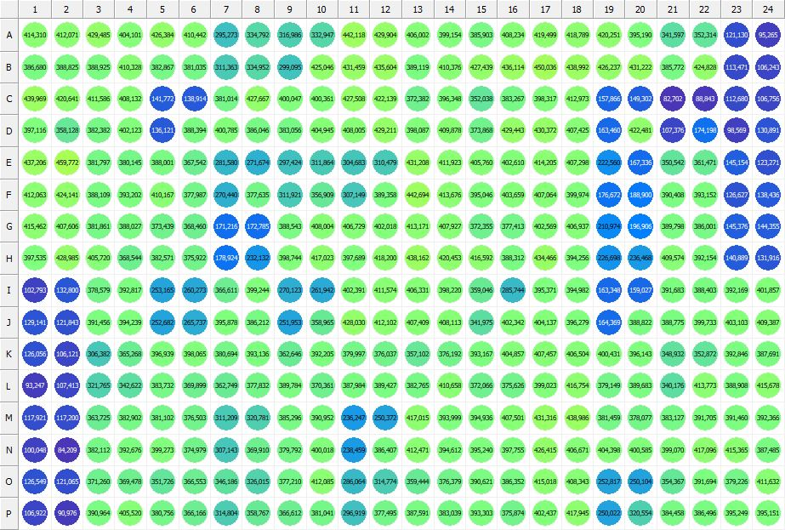

|  |
| --- |
| **Results for new alamar blue(1) - channel 1 (RFU)** |

|  |  |  |  |  |  |  |  |  |  |  |  |  |  |  |  |  |  |  |  |  |  |  |  |  |
| --- | --- | --- | --- | --- | --- | --- | --- | --- | --- | --- | --- | --- | --- | --- | --- | --- | --- | --- | --- | --- | --- | --- | --- | --- |
|  | 01 | 02 | 03 | 04 | 05 | 06 | 07 | 08 | 09 | 10 | 11 | 12 | 13 | 14 | 15 | 16 | 17 | 18 | 19 | 20 | 21 | 22 | 23 | 24 |
| A | 414310 | 412071 | 429485 | 404101 | 426384 | 410442 | 295273 | 334792 | 316986 | 332947 | 442118 | 429904 | 406002 | 399154 | 385903 | 408234 | 419499 | 418789 | 420251 | 395190 | 341597 | 352314 | 121130 | 95265 |
| B | 386680 | 388825 | 388925 | 410328 | 382867 | 381035 | 311363 | 334952 | 299095 | 425046 | 431459 | 435604 | 389119 | 410376 | 427439 | 436114 | 450036 | 438992 | 426237 | 431222 | 385772 | 424828 | 113471 | 106243 |
| C | 439969 | 420641 | 411586 | 408132 | 141772 | 138914 | 381014 | 427667 | 400047 | 400361 | 427508 | 422139 | 372382 | 396348 | 352038 | 383267 | 398317 | 412973 | 157866 | 149302 | 82702 | 88843 | 112680 | 106756 |
| D | 397116 | 358128 | 382382 | 402123 | 136121 | 388394 | 400785 | 386046 | 383056 | 404945 | 408005 | 429211 | 398087 | 409878 | 373868 | 429443 | 430372 | 407425 | 163460 | 422481 | 107376 | 174198 | 98569 | 130891 |
| E | 437206 | 459772 | 381797 | 380145 | 388001 | 367542 | 281580 | 271674 | 297424 | 311864 | 304683 | 310479 | 431208 | 411923 | 405760 | 402610 | 414205 | 407298 | 222560 | 167336 | 350542 | 361471 | 145154 | 123271 |
| F | 412063 | 424141 | 388109 | 393202 | 410167 | 377987 | 270440 | 377635 | 311921 | 356909 | 307149 | 389358 | 442694 | 413676 | 395046 | 403659 | 407064 | 399974 | 176672 | 188900 | 390408 | 393152 | 126627 | 138436 |
| G | 415462 | 407606 | 381861 | 388027 | 373439 | 368460 | 171216 | 172785 | 388543 | 408004 | 406729 | 402018 | 413171 | 407927 | 372355 | 377413 | 402569 | 406937 | 210974 | 196906 | 389798 | 386001 | 145376 | 144355 |
| H | 397535 | 428985 | 405720 | 368544 | 382571 | 375922 | 178924 | 232132 | 398744 | 417023 | 397689 | 418200 | 438162 | 420453 | 416592 | 388312 | 434466 | 394256 | 226698 | 236468 | 409574 | 392154 | 140889 | 131916 |
| I | 102793 | 132800 | 378579 | 392817 | 253165 | 260273 | 366611 | 399244 | 270123 | 261942 | 402391 | 411574 | 406331 | 398220 | 359046 | 285744 | 395371 | 394982 | 163348 | 159027 | 391683 | 388403 | 392169 | 401857 |
| J | 129141 | 121843 | 391456 | 394239 | 252682 | 265737 | 395878 | 386212 | 251953 | 358965 | 428030 | 412102 | 407409 | 408113 | 341975 | 402342 | 404137 | 396279 | 164369 | 388822 | 388775 | 399733 | 403103 | 409387 |
| K | 126056 | 106121 | 306382 | 365268 | 396939 | 398065 | 380694 | 393136 | 362646 | 392205 | 379997 | 376037 | 357102 | 376192 | 393167 | 404857 | 407457 | 406504 | 400431 | 396143 | 348932 | 352872 | 392846 | 387691 |
| L | 93247 | 107413 | 321765 | 342622 | 383732 | 369899 | 362749 | 377832 | 389784 | 370361 | 387984 | 389427 | 382765 | 410658 | 372066 | 375626 | 399023 | 416754 | 379149 | 389683 | 340176 | 413773 | 388908 | 415678 |
| M | 117921 | 117200 | 363725 | 382902 | 381102 | 376503 | 311209 | 320781 | 385296 | 390952 | 236247 | 250372 | 417015 | 393999 | 394936 | 407501 | 431316 | 438986 | 381459 | 378077 | 383127 | 391705 | 391460 | 392366 |
| N | 100048 | 84209 | 382112 | 392676 | 399273 | 374979 | 307143 | 369910 | 379792 | 400018 | 238459 | 386407 | 412471 | 394612 | 395240 | 397755 | 426415 | 406671 | 404398 | 400585 | 399070 | 417096 | 415365 | 387485 |
| O | 126549 | 121065 | 371260 | 369478 | 351726 | 366553 | 346186 | 326015 | 377210 | 412085 | 286064 | 314774 | 359444 | 376379 | 390621 | 386352 | 415018 | 408343 | 252817 | 250104 | 354367 | 391694 | 379226 | 411632 |
| P | 106922 | 90976 | 390964 | 405520 | 380756 | 366166 | 314804 | 358767 | 366612 | 381041 | 296919 | 377495 | 387591 | 383039 | 393303 | 375874 | 402437 | 417945 | 250022 | 320554 | 384458 | 386496 | 395249 | 395151 |

|  |  |
| --- | --- |
| **Plate information** | |
|  | |
| **Plate** | 2 |
| **Repeat** | 1 |
| **Barcode** |  |
| **Measured height** | 14.66 |
| **Inside temperature at start** | 23.44 |
| **Inside temperature at end** | 23.44 |
| **Humidity at start** | 52.9 |
| **Humidity at end** | 51.4 |
| **Ambient temperature at start** | 23.15 |
| **Ambient temperature at end** | 23.25 |
| **Group** | 1 |
| **Label** | new alamar blue(1) |
| **ScanX** | 0 |
| **ScanY** | 0 |
| **Measinfo** | De=1st Ex=Top Em=Top Wdw=N/A (14) |
| **Kinetics** | 0 |
| **Measurement date** | 6/30/2023 1:24:12 PM |
|  | |

|  |
| --- |
| **Background information** |
| Legend:  HDR1 - Plate  HDR2 - Label  HDR3 - Result  HDR4 - Signal  HDR5 - Flashes/Time  HDR6 - Meastime  HDR7 - MeasInfo |
| HDR1 HDR2 HDR3 HDR4 HDR5 HDR6 HDR7  2 new alamar blue 0 1409 1 00:00:00.000 De=1st Ex=Top Em=Top Wdw=N/A (14) |
|  |

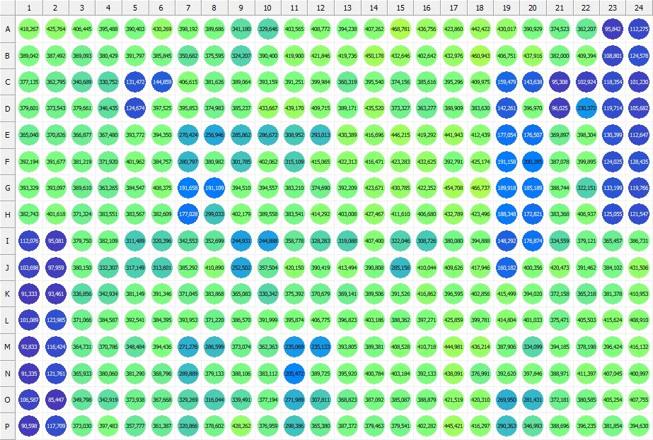

|  |
| --- |
| **Results for new alamar blue(1) - channel 1 (RFU)** |

|  |  |  |  |  |  |  |  |  |  |  |  |  |  |  |  |  |  |  |  |  |  |  |  |  |
| --- | --- | --- | --- | --- | --- | --- | --- | --- | --- | --- | --- | --- | --- | --- | --- | --- | --- | --- | --- | --- | --- | --- | --- | --- |
|  | 01 | 02 | 03 | 04 | 05 | 06 | 07 | 08 | 09 | 10 | 11 | 12 | 13 | 14 | 15 | 16 | 17 | 18 | 19 | 20 | 21 | 22 | 23 | 24 |
| A | 418267 | 425764 | 406445 | 395488 | 390403 | 430269 | 398192 | 389686 | 341180 | 329646 | 403565 | 408772 | 394238 | 407262 | 468781 | 436756 | 423860 | 442422 | 430017 | 390929 | 374523 | 362207 | 95842 | 112275 |
| B | 389042 | 387492 | 369093 | 380429 | 391797 | 385845 | 350682 | 375595 | 324207 | 390400 | 419900 | 421846 | 419736 | 450178 | 432646 | 402642 | 432976 | 460943 | 406751 | 437916 | 382000 | 409394 | 108801 | 124578 |
| C | 377135 | 362795 | 340689 | 330752 | 131472 | 144859 | 406615 | 381626 | 389064 | 393159 | 391251 | 399984 | 360319 | 395540 | 374156 | 385616 | 395296 | 409975 | 159479 | 143638 | 95308 | 102924 | 118354 | 101230 |
| D | 379601 | 373543 | 379661 | 346435 | 124674 | 397525 | 395853 | 374983 | 385237 | 433667 | 439170 | 409715 | 389171 | 435520 | 373327 | 363277 | 388909 | 383630 | 142261 | 396970 | 96025 | 230372 | 119714 | 105682 |
| E | 365040 | 370826 | 366877 | 367480 | 393772 | 394350 | 270424 | 256946 | 285862 | 286672 | 308952 | 293013 | 430389 | 416696 | 446215 | 419292 | 441943 | 412439 | 177054 | 176507 | 369897 | 398304 | 130399 | 112647 |
| F | 392194 | 391677 | 381219 | 371920 | 401962 | 384757 | 280797 | 380982 | 301785 | 402062 | 315109 | 415065 | 422313 | 416471 | 423283 | 432625 | 392791 | 425174 | 191158 | 200285 | 387078 | 399895 | 124025 | 128435 |
| G | 393329 | 393097 | 369610 | 363265 | 384547 | 408375 | 191658 | 191109 | 394510 | 394557 | 383210 | 374690 | 392209 | 423671 | 430785 | 422352 | 454708 | 466737 | 189918 | 185189 | 388744 | 322151 | 133199 | 119766 |
| H | 382743 | 401618 | 371324 | 383551 | 383567 | 382609 | 177028 | 299033 | 402179 | 389558 | 383541 | 414292 | 403008 | 427467 | 411610 | 406680 | 432789 | 423496 | 188348 | 172821 | 383368 | 406937 | 125055 | 121547 |
| I | 112076 | 95081 | 379750 | 382109 | 311489 | 320396 | 342553 | 352699 | 244931 | 244888 | 358778 | 328283 | 319088 | 407400 | 322046 | 308726 | 380080 | 394888 | 148292 | 176874 | 334559 | 379121 | 365457 | 386731 |
| J | 103698 | 97959 | 380150 | 332307 | 317149 | 313601 | 385292 | 410890 | 252502 | 357504 | 420150 | 390419 | 413494 | 390808 | 285156 | 410044 | 409626 | 417946 | 160182 | 400356 | 420473 | 391462 | 384102 | 431506 |
| K | 91333 | 93461 | 336856 | 342934 | 381149 | 391346 | 371045 | 383868 | 365083 | 330342 | 375392 | 370679 | 369141 | 389506 | 391526 | 416862 | 396595 | 402856 | 415499 | 394020 | 372158 | 365218 | 381378 | 410953 |
| L | 101089 | 123985 | 371066 | 384587 | 392541 | 384395 | 393953 | 371220 | 386570 | 391999 | 395874 | 406775 | 396823 | 403186 | 388362 | 397271 | 425859 | 399781 | 414804 | 401033 | 375471 | 405503 | 415624 | 408910 |
| M | 92833 | 116424 | 364731 | 370786 | 348484 | 394436 | 271276 | 286599 | 373074 | 362363 | 235069 | 235133 | 393805 | 389381 | 408528 | 410718 | 444981 | 436214 | 387906 | 334099 | 394185 | 378198 | 396424 | 416132 |
| N | 91335 | 121761 | 365933 | 380060 | 381290 | 368796 | 289889 | 379133 | 388106 | 383112 | 205472 | 389725 | 395920 | 400784 | 403184 | 392133 | 438091 | 376991 | 392620 | 397846 | 388971 | 411397 | 407045 | 400997 |
| O | 106587 | 85447 | 349798 | 342919 | 373938 | 367668 | 329269 | 316044 | 339491 | 377194 | 271989 | 307811 | 368823 | 387092 | 385087 | 388879 | 421519 | 420310 | 269950 | 281431 | 372181 | 380585 | 405254 | 407755 |
| P | 90598 | 117709 | 373030 | 397483 | 357777 | 361387 | 320866 | 378602 | 428262 | 376959 | 298386 | 365380 | 387372 | 379463 | 379541 | 402282 | 445421 | 416297 | 290363 | 346993 | 388696 | 396235 | 381854 | 394630 |

|  |  |
| --- | --- |
| **Plate information** | |
|  | |
| **Plate** | 3 |
| **Repeat** | 1 |
| **Barcode** |  |
| **Measured height** | 14.66 |
| **Inside temperature at start** | 23.44 |
| **Inside temperature at end** | 23.44 |
| **Humidity at start** | 51.4 |
| **Humidity at end** | 52.2 |
| **Ambient temperature at start** | 23.25 |
| **Ambient temperature at end** | 23.15 |
| **Group** | 1 |
| **Label** | new alamar blue(1) |
| **ScanX** | 0 |
| **ScanY** | 0 |
| **Measinfo** | De=1st Ex=Top Em=Top Wdw=N/A (14) |
| **Kinetics** | 0 |
| **Measurement date** | 6/30/2023 1:25:17 PM |
|  | |

|  |
| --- |
| **Background information** |
| Legend:  HDR1 - Plate  HDR2 - Label  HDR3 - Result  HDR4 - Signal  HDR5 - Flashes/Time  HDR6 - Meastime  HDR7 - MeasInfo |
| HDR1 HDR2 HDR3 HDR4 HDR5 HDR6 HDR7  3 new alamar blue 0 1527 1 00:00:00.000 De=1st Ex=Top Em=Top Wdw=N/A (14) |
|  |

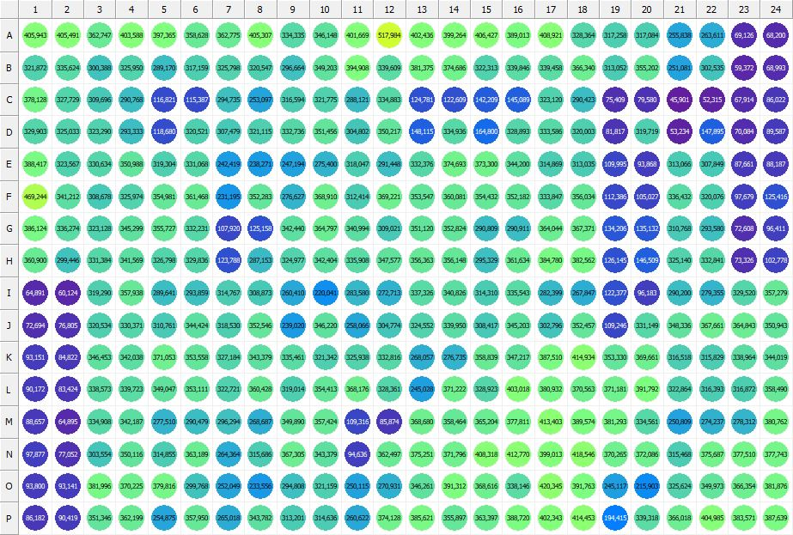

|  |
| --- |
| **Results for new alamar blue(1) - channel 1 (RFU)** |

|  |  |  |  |  |  |  |  |  |  |  |  |  |  |  |  |  |  |  |  |  |  |  |  |  |
| --- | --- | --- | --- | --- | --- | --- | --- | --- | --- | --- | --- | --- | --- | --- | --- | --- | --- | --- | --- | --- | --- | --- | --- | --- |
|  | 01 | 02 | 03 | 04 | 05 | 06 | 07 | 08 | 09 | 10 | 11 | 12 | 13 | 14 | 15 | 16 | 17 | 18 | 19 | 20 | 21 | 22 | 23 | 24 |
| A | 405943 | 405491 | 362747 | 403588 | 397365 | 358628 | 362775 | 405307 | 334335 | 346148 | 401669 | 517984 | 402436 | 399264 | 406427 | 389013 | 408921 | 328364 | 317258 | 317084 | 255838 | 263611 | 69126 | 68200 |
| B | 321872 | 335624 | 300388 | 325950 | 289170 | 317159 | 325798 | 320547 | 296664 | 349203 | 394908 | 339609 | 381375 | 374686 | 322313 | 339846 | 339458 | 366340 | 313052 | 355202 | 251081 | 302535 | 59372 | 68993 |
| C | 378128 | 327729 | 309696 | 290768 | 116821 | 115387 | 294735 | 253097 | 316594 | 321775 | 288121 | 334883 | 124781 | 122609 | 142209 | 145089 | 323120 | 290423 | 75409 | 79580 | 45901 | 52315 | 67914 | 86022 |
| D | 329903 | 325033 | 323290 | 293333 | 118680 | 320521 | 307479 | 321115 | 332736 | 351456 | 304802 | 350217 | 148115 | 334936 | 164800 | 328893 | 333586 | 320003 | 81817 | 319719 | 53234 | 147895 | 70084 | 89587 |
| E | 388417 | 323567 | 330634 | 350988 | 319304 | 331068 | 242419 | 238271 | 247194 | 275400 | 318047 | 291448 | 332376 | 374693 | 373300 | 344200 | 314869 | 313035 | 109995 | 93868 | 313066 | 307849 | 87661 | 88187 |
| F | 469244 | 341212 | 308678 | 325974 | 354981 | 361468 | 231195 | 352283 | 276627 | 368910 | 312414 | 369221 | 353547 | 360081 | 354432 | 352182 | 333847 | 356034 | 112386 | 105027 | 336432 | 320076 | 97679 | 125416 |
| G | 386124 | 336274 | 323128 | 345299 | 355727 | 332231 | 107920 | 125158 | 342440 | 364797 | 340994 | 309021 | 351120 | 352824 | 290809 | 290911 | 364044 | 367371 | 134206 | 135132 | 310768 | 293580 | 72608 | 96411 |
| H | 360900 | 299446 | 331384 | 341569 | 326798 | 329836 | 123788 | 287153 | 324977 | 342404 | 335908 | 347577 | 356363 | 356148 | 295329 | 361634 | 384780 | 382562 | 126145 | 146509 | 325140 | 332841 | 73326 | 102778 |
| I | 64891 | 60124 | 319290 | 357938 | 289641 | 293859 | 314767 | 308873 | 260410 | 220041 | 283580 | 272713 | 337326 | 340826 | 314310 | 335543 | 282399 | 267847 | 122377 | 96183 | 290200 | 279355 | 329520 | 357279 |
| J | 72694 | 76805 | 320534 | 330371 | 310761 | 344424 | 318530 | 352546 | 239020 | 346220 | 258066 | 304774 | 324552 | 339950 | 308417 | 345203 | 302796 | 352457 | 109246 | 331149 | 348336 | 367661 | 364843 | 350943 |
| K | 93151 | 84822 | 346453 | 342038 | 371053 | 353558 | 327184 | 343379 | 335461 | 321342 | 325938 | 332816 | 268057 | 276735 | 358839 | 347217 | 387510 | 414934 | 353330 | 369661 | 316518 | 315829 | 338964 | 344019 |
| L | 90172 | 83424 | 338573 | 339723 | 349047 | 353111 | 322721 | 360428 | 319014 | 354413 | 368176 | 328361 | 245028 | 371222 | 328923 | 403018 | 380932 | 370563 | 371181 | 391792 | 322864 | 316393 | 316872 | 358490 |
| M | 88657 | 64895 | 334908 | 342187 | 277510 | 290479 | 296294 | 268687 | 349890 | 357424 | 109316 | 85874 | 368680 | 358464 | 365204 | 377811 | 413403 | 389574 | 381293 | 334561 | 250809 | 274237 | 278312 | 380762 |
| N | 97877 | 77052 | 303554 | 350116 | 314855 | 363189 | 264364 | 315686 | 367305 | 343379 | 94636 | 362497 | 375251 | 371796 | 408318 | 412770 | 399013 | 418546 | 370265 | 372086 | 315468 | 375687 | 377510 | 377743 |
| O | 93800 | 93141 | 381996 | 370225 | 379816 | 299768 | 252049 | 233556 | 294808 | 321159 | 250115 | 270931 | 346261 | 391312 | 368616 | 338146 | 420345 | 391763 | 245117 | 215903 | 325624 | 349973 | 366354 | 381876 |
| P | 86182 | 90419 | 351346 | 362199 | 254875 | 357950 | 265018 | 343782 | 313201 | 314636 | 260622 | 374128 | 385621 | 355897 | 363397 | 388720 | 402343 | 414453 | 194415 | 339318 | 366018 | 404985 | 383571 | 387639 |

|  |  |
| --- | --- |
| **Plate information** | |
|  | |
| **Plate** | 4 |
| **Repeat** | 1 |
| **Barcode** |  |
| **Measured height** | 14.66 |
| **Inside temperature at start** | 23.54 |
| **Inside temperature at end** | 23.54 |
| **Humidity at start** | 51.9 |
| **Humidity at end** | 51.1 |
| **Ambient temperature at start** | 22.95 |
| **Ambient temperature at end** | 23.05 |
| **Group** | 1 |
| **Label** | new alamar blue(1) |
| **ScanX** | 0 |
| **ScanY** | 0 |
| **Measinfo** | De=1st Ex=Top Em=Top Wdw=N/A (14) |
| **Kinetics** | 0 |
| **Measurement date** | 6/30/2023 1:26:24 PM |
|  | |

|  |
| --- |
| **Background information** |
| Legend:  HDR1 - Plate  HDR2 - Label  HDR3 - Result  HDR4 - Signal  HDR5 - Flashes/Time  HDR6 - Meastime  HDR7 - MeasInfo |
| HDR1 HDR2 HDR3 HDR4 HDR5 HDR6 HDR7  4 new alamar blue 0 1463 1 00:00:00.000 De=1st Ex=Top Em=Top Wdw=N/A (14) |
|  |

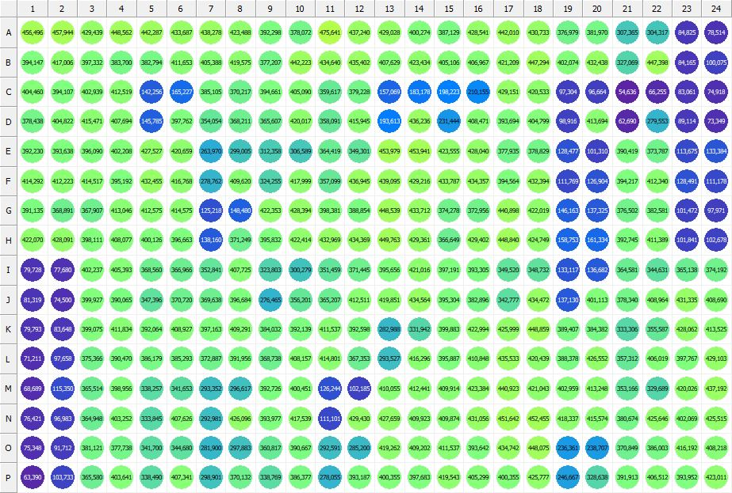

|  |
| --- |
| **Results for new alamar blue(1) - channel 1 (RFU)** |

|  |  |  |  |  |  |  |  |  |  |  |  |  |  |  |  |  |  |  |  |  |  |  |  |  |
| --- | --- | --- | --- | --- | --- | --- | --- | --- | --- | --- | --- | --- | --- | --- | --- | --- | --- | --- | --- | --- | --- | --- | --- | --- |
|  | 01 | 02 | 03 | 04 | 05 | 06 | 07 | 08 | 09 | 10 | 11 | 12 | 13 | 14 | 15 | 16 | 17 | 18 | 19 | 20 | 21 | 22 | 23 | 24 |
| A | 456496 | 457944 | 429439 | 448562 | 442287 | 433687 | 438278 | 423488 | 392298 | 378072 | 475641 | 437240 | 429028 | 400274 | 387129 | 428541 | 442010 | 430733 | 376979 | 381970 | 307365 | 304317 | 84825 | 78514 |
| B | 394147 | 417006 | 397332 | 383700 | 382794 | 411653 | 405388 | 419575 | 377207 | 442223 | 434640 | 435402 | 407629 | 423434 | 405106 | 406967 | 421209 | 447294 | 402074 | 432438 | 327069 | 447398 | 84165 | 100075 |
| C | 404460 | 394107 | 402939 | 412519 | 142256 | 165227 | 385105 | 370217 | 394661 | 405090 | 359617 | 379228 | 157069 | 183178 | 198223 | 210155 | 429151 | 420533 | 97304 | 96664 | 54636 | 66255 | 83061 | 74918 |
| D | 378438 | 404822 | 415471 | 407694 | 145785 | 397762 | 354054 | 368211 | 365607 | 420017 | 358091 | 415945 | 193613 | 436236 | 231444 | 408471 | 393694 | 404799 | 98916 | 413694 | 62690 | 279553 | 89114 | 73349 |
| E | 392230 | 393638 | 396090 | 402208 | 427527 | 420659 | 263970 | 299005 | 312358 | 306589 | 364419 | 349301 | 453979 | 453941 | 423555 | 428040 | 377935 | 378829 | 128477 | 101310 | 390419 | 373787 | 113675 | 133384 |
| F | 414292 | 412223 | 414517 | 395192 | 432455 | 416768 | 278762 | 409620 | 324255 | 417999 | 357099 | 436945 | 439095 | 429216 | 433787 | 434357 | 394564 | 432394 | 111769 | 126904 | 394217 | 412340 | 128491 | 111178 |
| G | 391135 | 368891 | 367907 | 413046 | 412575 | 414575 | 125218 | 148480 | 422353 | 428394 | 398381 | 388854 | 448539 | 433712 | 374278 | 372956 | 440898 | 422019 | 146163 | 137325 | 376502 | 382581 | 101472 | 97971 |
| H | 422070 | 428091 | 398111 | 408077 | 400126 | 396663 | 138160 | 371249 | 395832 | 422414 | 432969 | 434369 | 449763 | 429361 | 366649 | 429402 | 448840 | 424749 | 158753 | 161334 | 392745 | 411389 | 101841 | 102678 |
| I | 79728 | 77680 | 402237 | 405393 | 368560 | 366966 | 352841 | 407725 | 323803 | 300279 | 351459 | 371445 | 395656 | 421016 | 397191 | 393305 | 349520 | 348732 | 133117 | 136682 | 364581 | 344631 | 365138 | 374192 |
| J | 81319 | 74500 | 399927 | 390065 | 347396 | 370720 | 369638 | 396684 | 276465 | 356201 | 365207 | 412511 | 419851 | 434564 | 395304 | 382896 | 342777 | 434472 | 137130 | 401113 | 378340 | 408964 | 431335 | 408690 |
| K | 79793 | 83648 | 399075 | 411834 | 392064 | 408927 | 397163 | 409291 | 384032 | 392139 | 411537 | 392598 | 282988 | 331942 | 399883 | 422994 | 425999 | 448859 | 389407 | 384382 | 333306 | 355587 | 428062 | 413525 |
| L | 71211 | 97658 | 375366 | 390470 | 386179 | 385293 | 372887 | 391956 | 368738 | 408157 | 414801 | 367353 | 293527 | 416296 | 395887 | 410848 | 435533 | 420439 | 388378 | 426552 | 357312 | 406019 | 397767 | 429103 |
| M | 68689 | 115350 | 365514 | 398956 | 338257 | 341653 | 293352 | 296617 | 392726 | 400451 | 126244 | 102185 | 410055 | 412441 | 409914 | 423384 | 440923 | 421043 | 402959 | 413248 | 353166 | 329689 | 420026 | 437192 |
| N | 76421 | 96983 | 364948 | 403252 | 333845 | 407626 | 292981 | 426096 | 393977 | 417539 | 111101 | 429430 | 427659 | 409923 | 409874 | 431056 | 451642 | 452455 | 418337 | 415574 | 380674 | 425646 | 402069 | 425515 |
| O | 75348 | 91712 | 381121 | 377738 | 341700 | 344680 | 281900 | 297883 | 360817 | 390667 | 292591 | 285200 | 419262 | 409202 | 411537 | 393642 | 434742 | 448075 | 236361 | 238707 | 370849 | 386003 | 416192 | 408218 |
| P | 63390 | 103733 | 365580 | 403641 | 338490 | 407341 | 298901 | 370132 | 338769 | 386377 | 278055 | 393187 | 400355 | 397683 | 419543 | 405299 | 400355 | 425777 | 246667 | 328638 | 391913 | 406512 | 393952 | 423011 |

|  |  |
| --- | --- |
| **Plate information** | |
|  | |
| **Plate** | 5 |
| **Repeat** | 1 |
| **Barcode** |  |
| **Measured height** | 14.66 |
| **Inside temperature at start** | 23.54 |
| **Inside temperature at end** | 23.54 |
| **Humidity at start** | 52.5 |
| **Humidity at end** | 52.5 |
| **Ambient temperature at start** | 22.86 |
| **Ambient temperature at end** | 22.86 |
| **Group** | 1 |
| **Label** | new alamar blue(1) |
| **ScanX** | 0 |
| **ScanY** | 0 |
| **Measinfo** | De=1st Ex=Top Em=Top Wdw=N/A (14) |
| **Kinetics** | 0 |
| **Measurement date** | 6/30/2023 1:27:33 PM |
|  | |

|  |
| --- |
| **Background information** |
| Legend:  HDR1 - Plate  HDR2 - Label  HDR3 - Result  HDR4 - Signal  HDR5 - Flashes/Time  HDR6 - Meastime  HDR7 - MeasInfo |
| HDR1 HDR2 HDR3 HDR4 HDR5 HDR6 HDR7  5 new alamar blue 0 1324 1 00:00:00.000 De=1st Ex=Top Em=Top Wdw=N/A (14) |
|  |

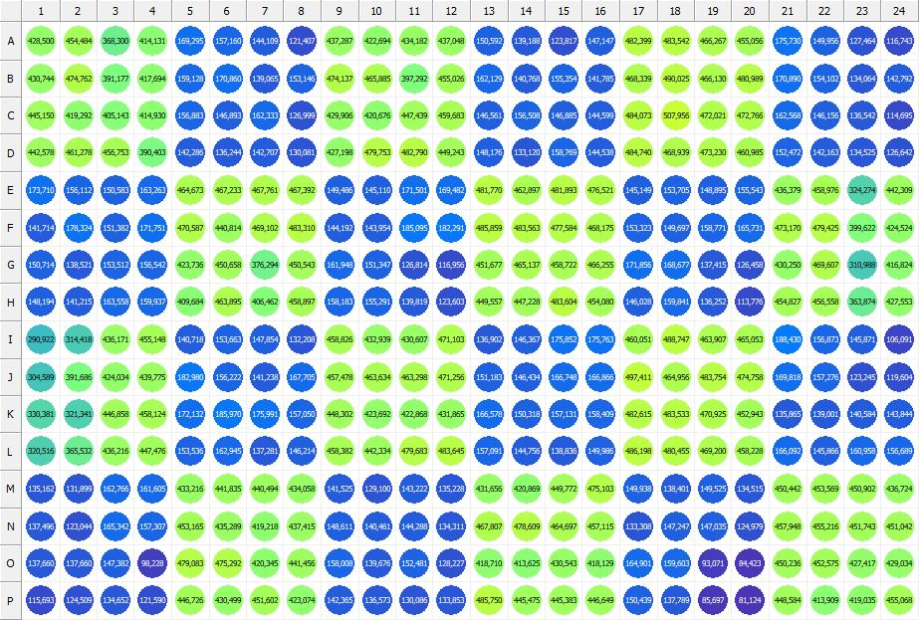

|  |
| --- |
| **Results for new alamar blue(1) - channel 1 (RFU)** |

|  |  |  |  |  |  |  |  |  |  |  |  |  |  |  |  |  |  |  |  |  |  |  |  |  |
| --- | --- | --- | --- | --- | --- | --- | --- | --- | --- | --- | --- | --- | --- | --- | --- | --- | --- | --- | --- | --- | --- | --- | --- | --- |
|  | 01 | 02 | 03 | 04 | 05 | 06 | 07 | 08 | 09 | 10 | 11 | 12 | 13 | 14 | 15 | 16 | 17 | 18 | 19 | 20 | 21 | 22 | 23 | 24 |
| A | 428500 | 454484 | 368300 | 414131 | 169295 | 157160 | 144109 | 121407 | 437287 | 422694 | 434182 | 437048 | 150592 | 139188 | 123817 | 147147 | 482399 | 483542 | 466267 | 455056 | 175730 | 149956 | 127464 | 116743 |
| B | 430744 | 474762 | 391177 | 417694 | 159128 | 170860 | 139065 | 153146 | 474137 | 465885 | 397292 | 455026 | 162129 | 140768 | 155354 | 141785 | 468339 | 490025 | 466130 | 480989 | 170890 | 154102 | 134064 | 142792 |
| C | 445150 | 419292 | 405143 | 414930 | 156883 | 146893 | 162333 | 126999 | 429906 | 420676 | 447439 | 459683 | 146561 | 156508 | 146885 | 144599 | 484073 | 507956 | 472021 | 472766 | 162568 | 146156 | 136542 | 114695 |
| D | 442578 | 461278 | 456753 | 390403 | 142286 | 136244 | 142707 | 130081 | 427198 | 479753 | 482790 | 449243 | 148176 | 133120 | 158769 | 144538 | 484740 | 468939 | 473230 | 460985 | 152472 | 142163 | 134525 | 126642 |
| E | 173710 | 156112 | 150583 | 163263 | 464673 | 467233 | 467761 | 467392 | 149486 | 145110 | 171501 | 169482 | 481770 | 462897 | 481893 | 476521 | 145149 | 153705 | 148895 | 155543 | 436379 | 458976 | 324274 | 442309 |
| F | 141714 | 178324 | 151382 | 171751 | 470587 | 440814 | 469102 | 483310 | 144192 | 143954 | 185095 | 182291 | 485859 | 483563 | 477584 | 468175 | 153323 | 149697 | 158771 | 165731 | 473170 | 479425 | 399622 | 424524 |
| G | 150714 | 138521 | 153512 | 156542 | 423736 | 450658 | 376294 | 450543 | 161948 | 151347 | 126814 | 116956 | 451677 | 465137 | 458722 | 466255 | 171856 | 168677 | 137415 | 126458 | 430250 | 469607 | 310988 | 416824 |
| H | 148194 | 141215 | 163558 | 159937 | 409684 | 463895 | 406462 | 458897 | 158183 | 155291 | 139819 | 123603 | 449557 | 447228 | 483604 | 454080 | 146028 | 159841 | 136252 | 113776 | 454827 | 456558 | 363874 | 427553 |
| I | 290922 | 314418 | 436171 | 455148 | 140718 | 153663 | 147854 | 132208 | 458826 | 432939 | 430607 | 471103 | 136902 | 146367 | 175852 | 175763 | 460051 | 488747 | 463907 | 465053 | 188430 | 156873 | 145871 | 106091 |
| J | 304589 | 391686 | 424034 | 439775 | 182980 | 156222 | 141238 | 167705 | 457478 | 463634 | 463298 | 471256 | 151183 | 146434 | 166748 | 166866 | 497411 | 464956 | 483754 | 474758 | 169818 | 157276 | 123245 | 119604 |
| K | 330381 | 321341 | 446858 | 458124 | 172132 | 185970 | 175991 | 157050 | 448302 | 423692 | 422868 | 431865 | 166578 | 150318 | 157131 | 158409 | 482615 | 483533 | 470925 | 452943 | 135865 | 139001 | 140584 | 143844 |
| L | 320516 | 365532 | 436216 | 447476 | 153536 | 162945 | 137281 | 146214 | 458382 | 442334 | 479683 | 483645 | 157091 | 144756 | 138836 | 149986 | 486198 | 480455 | 469200 | 458228 | 166092 | 145866 | 160958 | 156689 |
| M | 135162 | 131899 | 162766 | 161605 | 433216 | 441835 | 440494 | 434058 | 141525 | 129100 | 143222 | 135228 | 431656 | 420869 | 449772 | 475103 | 149938 | 138401 | 149525 | 134515 | 450442 | 453569 | 450902 | 436724 |
| N | 137496 | 123044 | 165342 | 157307 | 453165 | 435289 | 419218 | 437415 | 148611 | 140461 | 144288 | 134311 | 467807 | 478609 | 464697 | 457115 | 133308 | 147247 | 147035 | 124979 | 457948 | 455216 | 451743 | 451042 |
| O | 137660 | 137660 | 147382 | 98228 | 479083 | 475292 | 420345 | 441456 | 158008 | 139676 | 152481 | 128227 | 418710 | 413625 | 430543 | 418129 | 164901 | 159603 | 93071 | 84423 | 450236 | 452575 | 427417 | 429034 |
| P | 115693 | 124509 | 134652 | 121590 | 446726 | 430499 | 451602 | 423074 | 142365 | 136573 | 130086 | 133853 | 485750 | 445475 | 445383 | 446649 | 150439 | 137789 | 85697 | 81124 | 448584 | 413909 | 419035 | 455068 |

|  |  |
| --- | --- |
| **Plate information** | |
|  | |
| **Plate** | 6 |
| **Repeat** | 1 |
| **Barcode** |  |
| **Measured height** | 14.66 |
| **Inside temperature at start** | 23.54 |
| **Inside temperature at end** | 23.54 |
| **Humidity at start** | 51.9 |
| **Humidity at end** | 52.2 |
| **Ambient temperature at start** | 22.86 |
| **Ambient temperature at end** | 22.86 |
| **Group** | 1 |
| **Label** | new alamar blue(1) |
| **ScanX** | 0 |
| **ScanY** | 0 |
| **Measinfo** | De=1st Ex=Top Em=Top Wdw=N/A (14) |
| **Kinetics** | 0 |
| **Measurement date** | 6/30/2023 1:28:38 PM |
|  | |

|  |
| --- |
| **Background information** |
| Legend:  HDR1 - Plate  HDR2 - Label  HDR3 - Result  HDR4 - Signal  HDR5 - Flashes/Time  HDR6 - Meastime  HDR7 - MeasInfo |
| HDR1 HDR2 HDR3 HDR4 HDR5 HDR6 HDR7  6 new alamar blue 0 1356 1 00:00:00.000 De=1st Ex=Top Em=Top Wdw=N/A (14) |
|  |

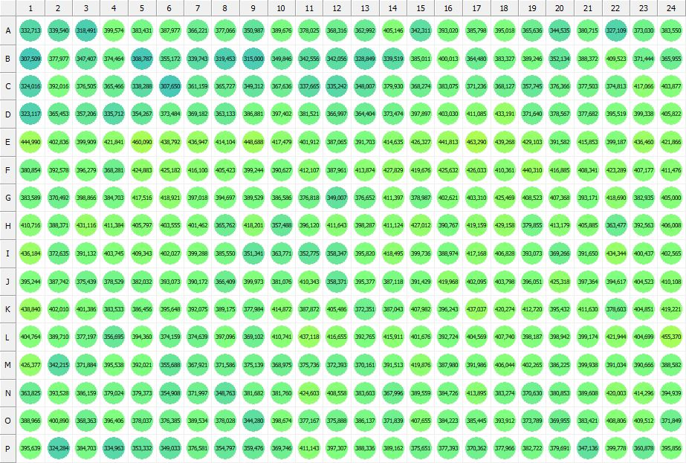

|  |
| --- |
| **Results for new alamar blue(1) - channel 1 (RFU)** |

|  |  |  |  |  |  |  |  |  |  |  |  |  |  |  |  |  |  |  |  |  |  |  |  |  |
| --- | --- | --- | --- | --- | --- | --- | --- | --- | --- | --- | --- | --- | --- | --- | --- | --- | --- | --- | --- | --- | --- | --- | --- | --- |
|  | 01 | 02 | 03 | 04 | 05 | 06 | 07 | 08 | 09 | 10 | 11 | 12 | 13 | 14 | 15 | 16 | 17 | 18 | 19 | 20 | 21 | 22 | 23 | 24 |
| A | 332713 | 339540 | 318491 | 399574 | 383431 | 387977 | 366221 | 377066 | 350987 | 389676 | 378025 | 368316 | 362992 | 405146 | 342311 | 393020 | 385798 | 395018 | 365636 | 344535 | 380715 | 327109 | 373030 | 383550 |
| B | 307509 | 377977 | 347407 | 374464 | 308787 | 355172 | 339743 | 319453 | 315000 | 349846 | 342556 | 342056 | 328849 | 339519 | 385011 | 400013 | 364480 | 383327 | 389246 | 352134 | 388372 | 409523 | 371444 | 365955 |
| C | 324016 | 392016 | 376505 | 365466 | 338288 | 307650 | 361159 | 365727 | 349312 | 367636 | 337665 | 335242 | 348007 | 379930 | 368274 | 383075 | 371236 | 368127 | 357745 | 376366 | 377503 | 374813 | 417066 | 403877 |
| D | 323117 | 365453 | 357206 | 335712 | 354267 | 373484 | 369182 | 363133 | 386881 | 397402 | 381521 | 366997 | 364404 | 373474 | 397897 | 403030 | 411085 | 433191 | 371640 | 378567 | 377682 | 395519 | 399338 | 405822 |
| E | 444990 | 402836 | 399909 | 421841 | 460090 | 438792 | 436947 | 414104 | 448688 | 417479 | 401912 | 387065 | 391703 | 414635 | 426327 | 441813 | 463290 | 439268 | 429103 | 391582 | 415853 | 399187 | 436460 | 421866 |
| F | 380854 | 392578 | 396279 | 368281 | 424883 | 425182 | 416100 | 405423 | 399244 | 390627 | 412107 | 387961 | 413874 | 427829 | 419676 | 425632 | 426033 | 410361 | 440310 | 416885 | 408341 | 423289 | 407177 | 411476 |
| G | 383589 | 370492 | 398866 | 384703 | 417516 | 418921 | 397018 | 394697 | 389529 | 386586 | 376818 | 349007 | 376652 | 411397 | 378987 | 402621 | 403310 | 425469 | 408523 | 407368 | 393171 | 418690 | 382935 | 405000 |
| H | 410716 | 388371 | 431116 | 411384 | 405797 | 403555 | 401462 | 365762 | 418201 | 357488 | 396120 | 411643 | 398287 | 411124 | 427012 | 390767 | 419159 | 429158 | 379855 | 413179 | 405885 | 363477 | 392563 | 406008 |
| I | 436184 | 372635 | 391132 | 403745 | 409343 | 402027 | 399288 | 385550 | 351341 | 363771 | 352775 | 358347 | 395820 | 418495 | 399736 | 388974 | 417168 | 406828 | 393073 | 369266 | 391650 | 434344 | 400437 | 402565 |
| J | 395244 | 387742 | 375439 | 378529 | 382032 | 393073 | 390172 | 366409 | 399973 | 381076 | 410343 | 358371 | 395377 | 387118 | 391429 | 419968 | 402095 | 403798 | 396051 | 425318 | 397364 | 394617 | 404523 | 410108 |
| K | 438840 | 402010 | 401386 | 383533 | 386456 | 395648 | 392075 | 389175 | 377984 | 414872 | 387872 | 405486 | 372351 | 387043 | 407982 | 396243 | 437037 | 420274 | 412720 | 395432 | 411630 | 378603 | 404851 | 419221 |
| L | 404764 | 389710 | 377197 | 356695 | 394360 | 374159 | 374639 | 397096 | 369102 | 410741 | 437118 | 416655 | 392765 | 415911 | 401676 | 392724 | 404569 | 407740 | 398187 | 398942 | 399174 | 421944 | 404699 | 455370 |
| M | 426377 | 342215 | 371884 | 395538 | 392021 | 355688 | 367921 | 371586 | 375139 | 368975 | 375736 | 372393 | 370161 | 391513 | 419876 | 387980 | 391986 | 406044 | 402265 | 386225 | 399938 | 391034 | 390666 | 388582 |
| N | 363825 | 393528 | 386159 | 379024 | 379373 | 354908 | 371997 | 348763 | 381682 | 381760 | 424603 | 408558 | 383603 | 367996 | 389559 | 384726 | 413895 | 383274 | 370630 | 380853 | 389608 | 420003 | 414296 | 394939 |
| O | 388966 | 400890 | 368363 | 396406 | 378037 | 376385 | 389534 | 378028 | 344280 | 398674 | 377167 | 375888 | 386137 | 371839 | 407655 | 384223 | 385445 | 393912 | 373789 | 369955 | 383421 | 408806 | 409512 | 371849 |
| P | 395639 | 324284 | 384703 | 334963 | 353332 | 349033 | 376581 | 354797 | 359476 | 369746 | 411143 | 397307 | 388336 | 389162 | 375651 | 377393 | 370362 | 377966 | 382722 | 379691 | 347136 | 399778 | 360878 | 395856 |

|  |  |
| --- | --- |
|  | |
| **Basic assay information** | |
| **Assay ID** | 25552 |
| **Assay Started** | 6/30/2023 1:22:22 PM |
| **Assay Finished** | 6/30/2023 1:29:01 PM |
| **Assay Exported** | 6/30/2023 3:31:35 PM |
| **Protocol ID** | 100177 |
| **Protocol Name** | TRF-384 Alamar blue+BS+nbw |
| **Serial#** | 1020141 |
|  | |
|  | |
|  | |
| **Protocol information** | |
| **Protocol:** | |
| **Protocol name** | TRF-384 Alamar blue+BS+nbw |
| **Number of assay repeats** | 1 |
| **Start assay repeat each** | N/A |
| **Number of plate repeats** | 1 |
| **Start plate repeat each** | N/A |
| **Is label meas. height used** | Yes |
| **Height of measurement** | Defined in label |
| **Is gripper height used** | No |
| **Mode of measurement** | By Rows, bi-directional |
| **Rotated plate** | No |
| **Soft move** | No |
| **Protocol notes** |  |
|  | |
| **Plate type:** | |
| **Name of the plate type** | Jaffe 384 General |
| **Number of rows** | 16 |
| **Number of columns** | 24 |
| **Number of the wells in the plate** | 384 |
| **Height of the plate** | 14.35 mm |
|  | |
| **Coordinates of corners:** | |
| **Jaffe 384 General** | |
| 12.13 mm x------------------------------------------------------ x 115.63 mm  8.99 mm 8.99 mm | |
| 12.13 mm x------------------------------------------------------ x 115.63 mm  76.49 mm 76.49 mm | |
|  | |
|  | |

|  |  |
| --- | --- |
| **Platemap:** | |
| **Plate** | 1 |
| **Group** | 1 |
|  | |

|  |  |  |  |  |  |  |  |  |  |  |  |  |  |  |  |  |  |  |  |  |  |  |  |  |
| --- | --- | --- | --- | --- | --- | --- | --- | --- | --- | --- | --- | --- | --- | --- | --- | --- | --- | --- | --- | --- | --- | --- | --- | --- |
|  | **01** | **02** | **03** | **04** | **05** | **06** | **07** | **08** | **09** | **10** | **11** | **12** | **13** | **14** | **15** | **16** | **17** | **18** | **19** | **20** | **21** | **22** | **23** | **24** |
| **A** | - | - | - | - | - | - | - | - | - | - | - | - | - | - | - | - | - | - | - | - | - | - | - | - |
| **B** | - | - | - | - | - | - | - | - | - | - | - | - | - | - | - | - | - | - | - | - | - | - | - | - |
| **C** | - | - | - | - | - | - | - | - | - | - | - | - | - | - | - | - | - | - | - | - | - | - | - | - |
| **D** | - | - | - | - | - | - | - | - | - | - | - | - | - | - | - | - | - | - | - | - | - | - | - | - |
| **E** | - | - | - | - | - | - | - | - | - | - | - | - | - | - | - | - | - | - | - | - | - | - | - | - |
| **F** | - | - | - | - | - | - | - | - | - | - | - | - | - | - | - | - | - | - | - | - | - | - | - | - |
| **G** | - | - | - | - | - | - | - | - | - | - | - | - | - | - | - | - | - | - | - | - | - | - | - | - |
| **H** | - | - | - | - | - | - | - | - | - | - | - | - | - | - | - | - | - | - | - | - | - | - | - | - |
| **I** | - | - | - | - | - | - | - | - | - | - | - | - | - | - | - | - | - | - | - | - | - | - | - | - |
| **J** | - | - | - | - | - | - | - | - | - | - | - | - | - | - | - | - | - | - | - | - | - | - | - | - |
| **K** | - | - | - | - | - | - | - | - | - | - | - | - | - | - | - | - | - | - | - | - | - | - | - | - |
| **L** | - | - | - | - | - | - | - | - | - | - | - | - | - | - | - | - | - | - | - | - | - | - | - | - |
| **M** | - | - | - | - | - | - | - | - | - | - | - | - | - | - | - | - | - | - | - | - | - | - | - | - |
| **N** | - | - | - | - | - | - | - | - | - | - | - | - | - | - | - | - | - | - | - | - | - | - | - | - |
| **O** | - | - | - | - | - | - | - | - | - | - | - | - | - | - | - | - | - | - | - | - | - | - | - | - |
| **P** | - | - | - | - | - | - | - | - | - | - | - | - | - | - | - | - | - | - | - | - | - | - | - | - |

|  |  |
| --- | --- |
|  | |
| **-** | Undefined |
|  | |
|  | |

|  |  |
| --- | --- |
| **Calculations:** | |
| **No calculations.** | |
|  | |
| **Auto export parameters:** | |
| **Export format** | Plate2 |
| **Include basic assay information** | Yes |
| **Place assay information at** | End of file |
| **Include basic plate information** | Yes |
| **Place plate information at** | End of plate |
| **Include protocol information** | Yes |
| **Protocol info level** | Large |
| **Include error and warning information** | Yes |
| **Include background information** | Yes |
| **Add plate number to the file name** | Yes |
| **Each plate to separate file** | No |
| **Field separator to use** | System |
| **File name format** | <DefaultDataFolder>\<Date>\<ProtocolName>_<AssayID>.csv |
|  | |
| **Operations:** | |
| Plate 1  Group 1  Measurement  Label..................................................... new alamar blue(1) | |
| **Labels:** | |
| **new alamar blue** | 4000013 |
| **Top mirror** | General |
| **Bottom mirror** | N/A |
| **Exc. filter** | Photometric 530 |
| **Using of excitation filter** | Top |
| **2nd exc. filter** | N/A |
| **Using of 2nd excitation filter** | Top |
| **Ems. filter** | Photometric 590 |
| **2nd ems. filter** | N/A |
| **Measurement height** | 6.5 mm |
| **Number of flashes** | 1 |
| **Number of flashes integrated** | 1 |
| **PMT gain** | 1 |
| **Excitation light** | 0% |
| **Reference excitation light** | 100% |
| **Emission light** | 100% |
| **Reference AD gain** | 2 |
| **Reference signal** | 256388 |
| **Last edited** | 10/13/2006 11:04:00 AM |
| **Last edited by** | EnVision |
| **Factory preset** | No |
|  | |
| **Filters:** | |
| **Photometric 530** | 310 |
| **Filter type** | Excitation |
| **Description** | P530 CWL=530nm BW=8nm Tmin=55% |
| **Used with** | Absorbance,DELFIA - Time-resolved Fluorescence,Fluorescence Intensity,Fluorescence Polarization,LANCE - Time-resolved Fluorescence |
| **Last edited** | 5/24/2023 12:39:03 PM |
| **Last edited by** | Installation |
| **Factory preset** | Yes |
|  | |
| **Photometric 590** | 314 |
| **Filter type** | Excitation |
| **Description** | P590 CWL=590nm BW=8nm Tmin=40% |
| **Used with** | Absorbance,DELFIA - Time-resolved Fluorescence,Fluorescence Intensity,Fluorescence Polarization,LANCE - Time-resolved FluorescenceAbsorbance,DELFIA - Time-resolved Fluorescence,Fluorescence Intensity,Fluorescence Polarization,LANCE - Time-resolved Fluorescence |
| **Last edited** | 5/24/2023 12:39:03 PM |
| **Last edited by** | Installation |
| **Factory preset** | Yes |
|  | |
| **Mirror modules:** | |
| **General** | 401 |
| **Used by** | Top |
| **Dual** | No |
| **Bias** | No |
| **Description** | BS50 |
| **Used with** | Luminescence,DELFIA - Time-resolved Fluorescence,Fluorescence Intensity,Fluorescence Polarization,LANCE - Time-resolved Fluorescence |
| **Last edited** | 5/24/2023 12:39:03 PM |
| **Last edited by** | Installation |
| **Factory preset** | Yes |
|  | |
| **Instrument:** | |
| **Serial number** | 1020141 |
| **Nickname** | EnVision |
|  | |
|  | |
|  | |
|  | |
| **Notifications:** | |
| Assay notifications:  INFO: Assay aborted at plate 6 plate repeat 1 and well P01. There may be missing results | |
|  | |
|  | |

|  |
| --- |
|  |
| **Exported with EnVision Workstation version 1.14.3049.1534** |